**BUSINESS INTELLIGENCE AND BUSINESS ANALYTICS**

**PROJECT SPECIFICATION DOCUMENT**

**SUBMITTED TO,**

**PROF. SEAN HEENEY**

**15-04-2020**

**SUBMITTED BY,**

**ARUNKUMAR SUDHAKARAN NAIR (19153317)**

**EVLIN BRIDGIT EMMANUEL (19153813)**

**MONISHA NAGESH (18193803)**

**ARATHY VIJAYAN (19148615)**

**Contents**

**1.** **Abstract:** 3

**2.** **Background Information:** 3

**3.** **Marketplace:** 3

**4.** **Scope of the Process:** 3

**5.** **System Design:** 4

**5.1.** **Architectural Design:** 4

**5.2.** **Logical Design:** 4

**5.3.** **Physical Design:** 5

**6. Data Capture Points:** 7

**7. Analytics Requirements:** 7

**8.** **Customer Integration:** 7

**9.** **Data Dictionary:** 8

**References:** 9

# **Abstract:**

The project aims at providing an effective business solution for controlling the fraudulent activities going on in the e-commerce space in the current era. For this purpose, we have chosen the e-commerce organisation Wish.com. We are trying to bring in a BI solution which identifies the fraudulent activities and thereby increasing the company revenue and customer satisfaction.

# **Background Information:**

Wish.com was founded in 2010 by Piotr Szulczewski (CEO), James Prendergast (COO) and Danny Zhang (former CTO). Wish is operated by ContextLogic Inc. in San Francisco. Instead of relying on a search bar interface, the platform employs browsing technologies that visually personalize shopping for each customer.

Wish.com is an online e-commerce platform which promotes seller-buyer transactions. It provides an opportunity for the sellers to sell their items directly to the buyers by listing them on Wish.com. To summarize, Wish.com serves as a mediator in managing payments but does not store the items themselves or handle returns. However, due to this feature itself, Wish.com has been criticized for listing low quality or falsified goods.

# **Marketplace:**

With offices around the globe from the United States to Europe, Wish.com is one of the largest cross-border e-commerce marketplaces and is the 6th largest e-commerce company too.

# **Scope of the Process:**

As a part of our project we have identified that even though leading in multiple areas, the major area where Wish.com needs improvement is in managing the fraud system. For this, we are introducing two different approaches using BI tools which will reduce the number of counterfeit products in the platform.

**Identifying the fraudulent sellers on the platform based on Customer Reviews**

By implementing the BI model, we are aiming at reducing the number of fraudulent sellers in the Wish.com platform. For this, we are designing a customer review form which we are collecting ratings and reviews from our customers regarding the products which they purchased. Further, we will filter out the ratings based on a threshold value and will evaluate the sellers having the ratings below the threshold value

# **System Design:**

System design is the process of identifying, creating and implementing systems that addressed a company's or organization's specific needs and requirements. Here, the entire problem is broken down into smaller parts, and the different small solutions are then combined as a complete solution.

## **Architectural Design:**

The architectural design of a system is concerned with learning how to organize a system and the overall function of the system. A system's architectural design emphasizes on the system design, the structure, behaviour, and more views of that system, and study.

As a majority of the E-commerce systems, our model also follows a 3-tier, client-server architecture. The 3-tier architecture comprises of the top-tier, middle-tier and the third-tier. The top-tier is for the user interface, the middle-tier includes the process management and the third-tier includes the database management section. An outline of the 3-tier architecture is shown below:

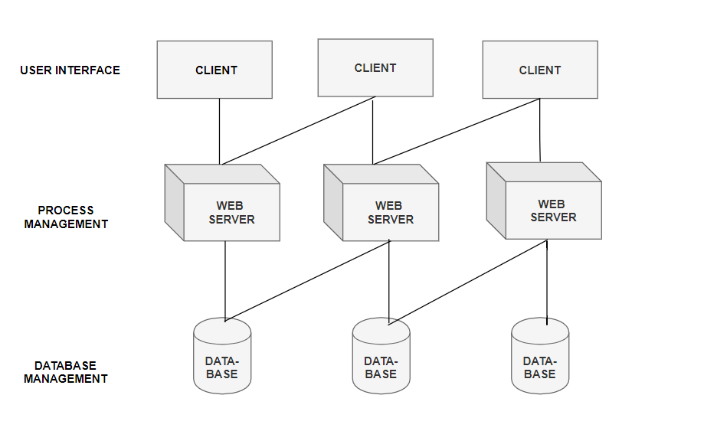

## **Logical Design:**

The logical design of a system can be referred to as an abstract representation of the data flows, inputs and outputs of the system. The Entity-Relationship diagram is used to represent the logical design of a system. The logical design of our model can be represented as follows:

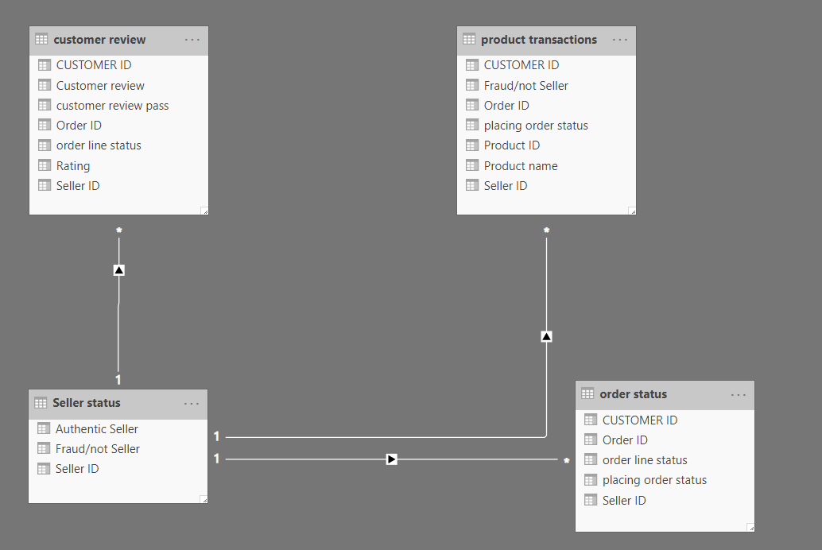

From the ER diagram, it can be understood that the entities are having many to one relationship with each other. To be precise, in our organisation multiple customers are related to a single seller.

## **Physical Design:**

The physical design of the system is used to explain how the data input is done in the system, the processing of the data, verifying the authenticity of the data and the output process for the data. In our model, we are focusing on verifying the authenticity of the data. For this, we are considering the fraudulent transactions in our Organisation considered, ie, Wish.com.

One of the key factors in determining the fraudulent transaction is the reviews which we collect from the buyers/customers. To effectively implement this system, we have created a feedback form through which we are collecting the customer reviews and ratings for different products.

The form can be accessed from the below link:

<https://form.jotform.com/200993262645055>

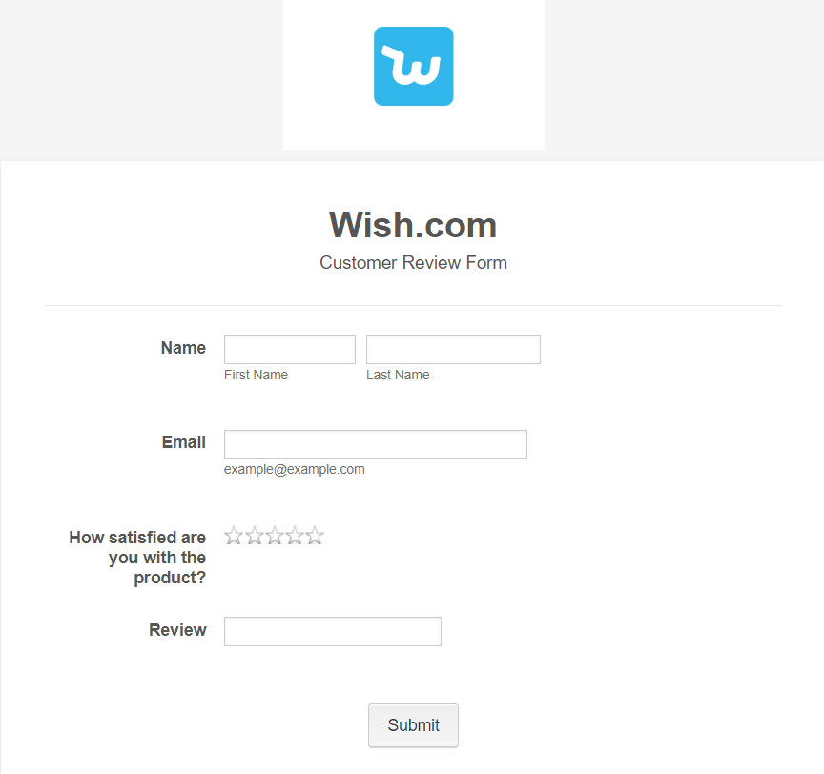

From the customer feedback obtained, we are trying to evaluate our seller. If a particular seller is constantly getting fewer ratings and negative reviews from multiple customers we will consider the possibility for the seller to be a fraudulent seller on the platform and will move the seller for further verification.

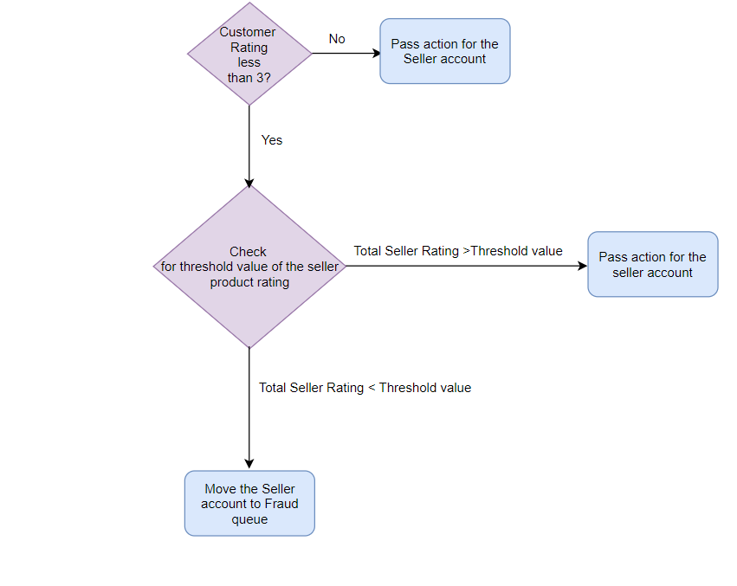

# **6. Data Capture Points:**

The below listed are data capture points considered in our BI solution:

|  |  |  |
| --- | --- | --- |
| **Data Capture Points** | | **Data Captured** |
| Feedback form | Online feedback form which is used to collect the reviews and the ratings.  <https://form.jotform.com/200993262645055> | Through the feedback form, we are capturing the ratings provided by the buyers for particular products and maps them to sellers, if any seller is consistently getting negative reviews, we will move the sellers to a fraudulent queue |

# **7. Analytics Requirements:**

To implement our BI solution, it is important to collect data and analyse the same. To collect the feedback from the buyers who are purchasing through Wish.com, we have implemented a feedback form through which the customers can post their ratings.



We are focusing on the ratings from the customers on each product to asses the sellers on the platform.

# **Customer Integration:**

In our model, the customer is the centre of focus. To carry out the analysis we need the feedback from the customers/buyers. We are integrating the customers in our model through the implementation of the feedback form. Also, we have loaded 10 dummy customers as Accounts into our CRM module for further implementation of our model.

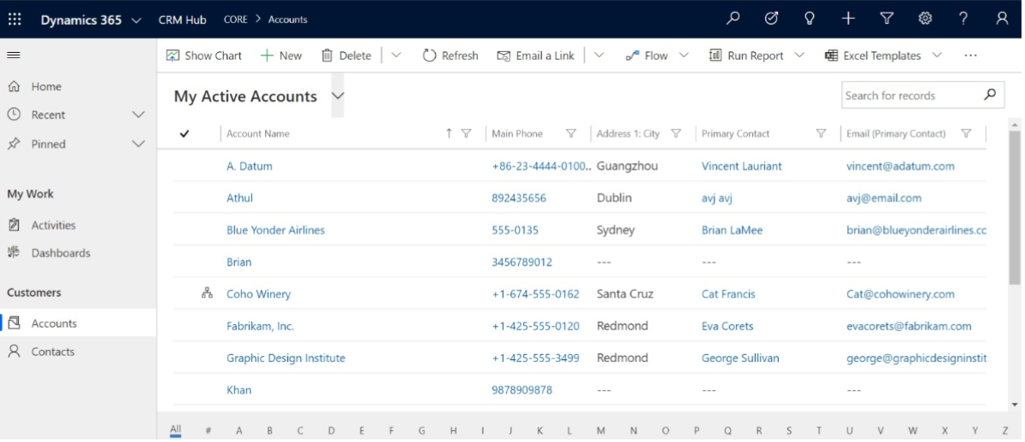

# **Data Dictionary:**

Data Dictionary is a document which describes the key terminologies in a business process. The data dictionary for our model is shown below. The data types used and the key variables which are used for the BI solution are mentioned in the data dictionary.

|  |  |  |  |
| --- | --- | --- | --- |
| D**epartment** | **Term** | **Definition** | **Data Type** |
|  | Name | An entity which is used to describe the seller. | String with 100 characters limit |
| **S**  **A**  **L**  **E**  **S** | Customer Rating | Customer Rating is used to measure the satisfaction level of the customer on buying a product supplied by the seller on a scale of 1 to 5. | Integer with min value 1 and max value 5 |
|  | Seller Status | Seller status can be defined as the category in which the seller can be grouped. | The boolean data type (edited and customised to fraudulent and not fraudulent) |
|  |  |  |  |
| **Customer Service** | Accounts | An entity which holds several customer records. | String |

# **References:**

[1] "Wish (company)", En.wikipedia.org, 2020. [Online]. Available: https://en.wikipedia.org/wiki/Wish_(company). [Accessed: 11- Apr- 2020].

[2] "Systems design", En.wikipedia.org, 2020. [Online]. Available: https://en.wikipedia.org/wiki/Systems_design. [Accessed: 11- Apr- 2020]